E-Commerce Business Intelligence Dashboard
End-to-End Power BI Case Study & Project Documentation
Prepared by: Harsh Choudhary

Executive Summary
This project demonstrates the complete Business Intelligence lifecycle using the Olist Brazilian E-Commerce dataset. The objective was to transform raw transactional data into an interactive Power BI solution that enables business leaders to monitor sales performance, customer behaviour, product performance, seller effectiveness, customer satisfaction, and logistics operations.
The report follows an end-to-end workflow beginning with business understanding, followed by data preparation, data modelling, DAX development, dashboard design, and business insight generation. The final solution contains six interactive dashboard pages supported by a star schema data model and reusable DAX measures.

Business Problem
E-commerce businesses generate thousands of transactions every day. Without a centralized reporting solution, management teams struggle to answer important questions such as:
• Which products generate the highest revenue?
• Which customers contribute the most value?
• Which sellers perform best?
• Which regions experience delivery delays?
• How does delivery performance affect customer satisfaction?
The purpose of this project is to answer these questions through an interactive Business Intelligence dashboard.
Dataset
Dataset Name: Brazilian E-Commerce Public Dataset by Olist
Source: Kaggle
Dataset Link:
https://www.kaggle.com/datasets/olistbr/brazilian-ecommerce
Description:
The dataset contains approximately 100,000 e-commerce orders placed on the Olist Store between 2016 and 2018. It includes customer information, order details, products, sellers, payments, reviews, and geolocation data. This dataset was used to perform end-to-end business intelligence analysis, build a star schema data model, create DAX measures, and develop interactive Power BI dashboards.
Dataset Tables Used:
- olist_customers_dataset.csv
- olist_orders_dataset.csv
- olist_order_items_dataset.csv
- olist_order_payments_dataset.csv
- olist_order_reviews_dataset.csv
- olist_products_dataset.csv
- olist_sellers_dataset.csv
- product_category_name_translation.csv

Project Objectives
1. Build a scalable star-schema data model.
2. Clean and transform raw data using Power Query.
3. Create reusable DAX measures for KPIs.
4. Design executive dashboards for different business domains.
5. Deliver actionable business insights and recommendations.

Dataset Description
Dataset: Olist Brazilian E-Commerce Public Dataset
Main Tables:
• Customers – Customer demographics and location.
• Orders – Order lifecycle and timestamps.
• Order Items – Products purchased in each order.
• Products – Product information and dimensions.
• Sellers – Seller location and details.
• Payments – Payment methods and transaction values.
• Reviews – Customer ratings and comments.
• Category Translation – Portuguese to English category mapping.
The Orders table acts as the central business process and connects to multiple dimension tables through foreign keys.

Data Preparation
Power Query was used as the ETL layer.
Transformation activities included:
• Validating data types
• Removing duplicates
• Handling null values
• Renaming columns
• Creating Product Volume
• Creating Delivery Days
• Building a dedicated Date table
• Preparing clean analytical tables
These transformations improve model performance and reporting accuracy.

Data Model
A Star Schema was selected because it is the recommended modelling approach for Power BI.
Fact Tables:
• Order Items
• Payments
Dimension Tables:
• Customers
• Products
• Sellers
• Reviews
• Date
• Category Translation
Benefits:
• Faster query performance
• Simpler DAX
• Easier maintenance
• Better scalability
(Insert your Model View screenshot here.)

DAX Measures
Key measures created:
• Total Revenue
• Total Orders
• Total Customers
• Average Order Value
• Average Rating
• Products Sold
• Average Delivery Days
• Total Freight Cost
• Revenue per Customer
Each measure was created to answer a specific business question rather than simply displaying numbers. Include your DAX formulas and explain why each measure is important.

Dashboard Design
Page 1 – Executive Overview
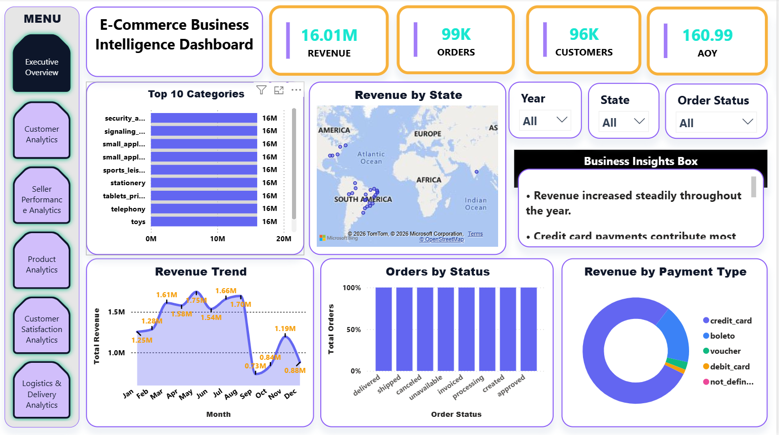
Purpose: Provide executives with a high-level business summary through KPIs, revenue trends, geographical analysis and payment insights.

- Total revenue exceeded 16.01M, demonstrating strong overall business performance.
- Customer ratings remained above 4.0, indicating high customer satisfaction.
- Credit card payments accounted for the majority of transactions and revenue.
- Revenue showed consistent growth during the primary sales period.
- Sales were concentrated in a few key states, highlighting important regional markets.

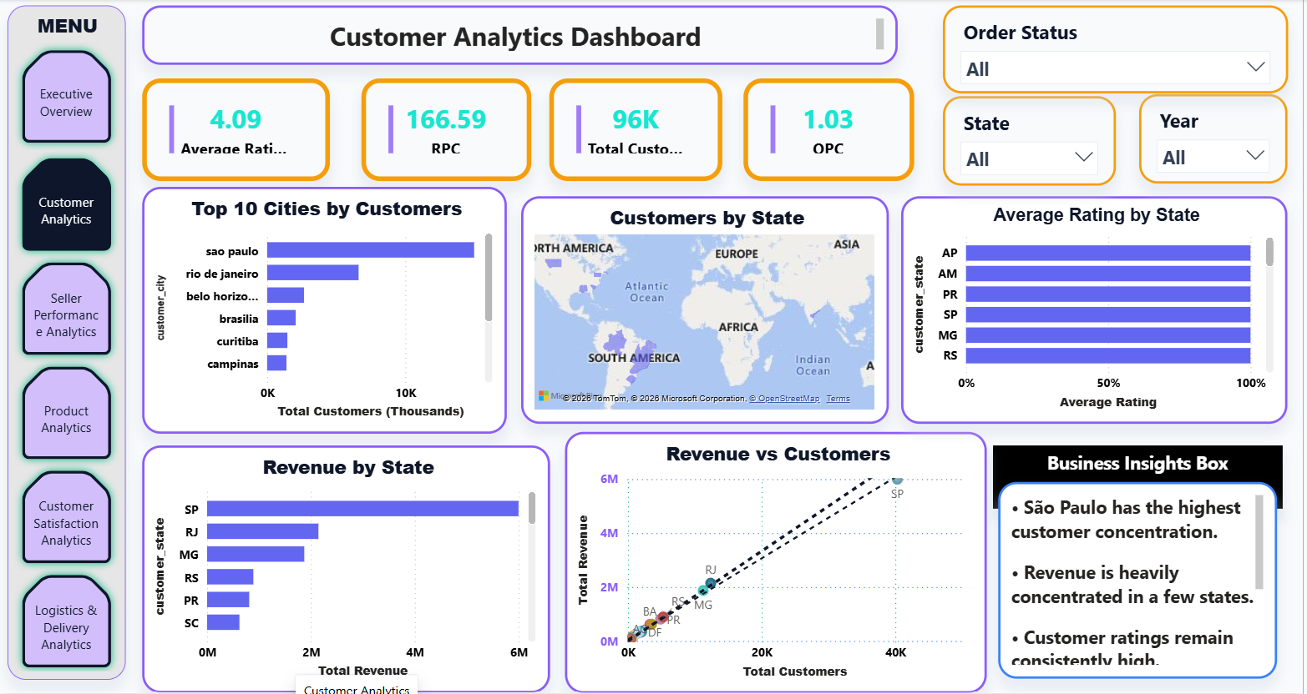
Page 2 – Customer Analytics
Purpose: Understand customer distribution, spending behaviour and regional performance.

- São Paulo contributed the largest share of the customer base.
- Revenue generation is concentrated among a relatively small group of customers.
- Average revenue per customer indicates strong customer purchasing behavior.
- Customer satisfaction remained consistently high across most regions.
- Expanding marketing efforts in low-customer regions could increase overall sales.

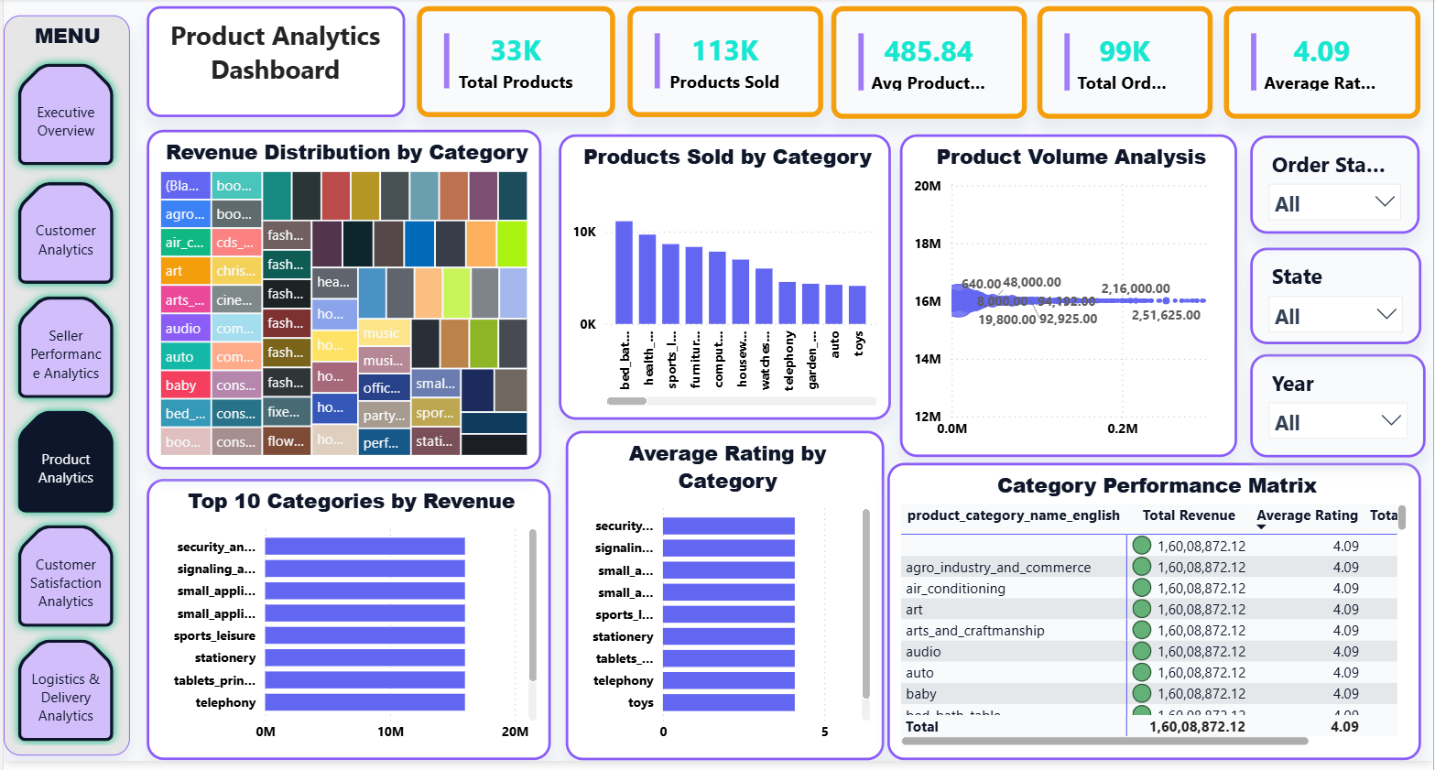
Page 3 – Product Analytics
Purpose: Identify high-performing categories, analyse ratings and evaluate product performance.

- The top product categories generated the highest share of total revenue.
- Product sales were concentrated in a limited number of high-performing categories.
- Most product categories maintained customer ratings above 4 stars.
- Large product categories incurred higher logistics and freight costs.
- Optimizing low-performing categories could improve overall profitability.

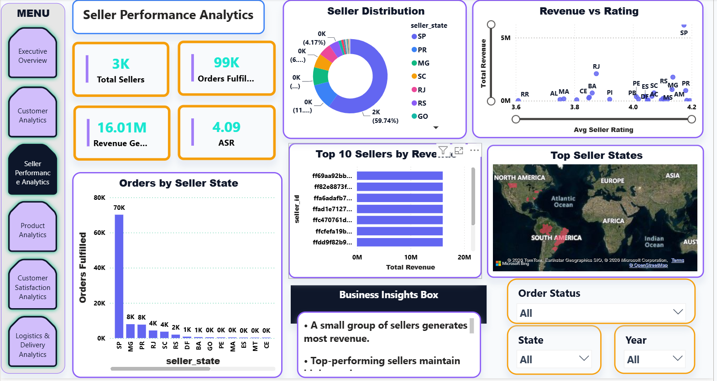
Page 4 – Seller Performance
Purpose: Compare sellers using revenue, orders and ratings.

  - A small percentage of sellers generated the majority of total revenue.
  - Top-performing sellers consistently maintained higher customer ratings.
  - Seller activity was concentrated in a few major states.
  - Revenue and seller performance showed a positive relationship with customer satisfaction.
  - Supporting lower-performing sellers presents an opportunity for business growth.

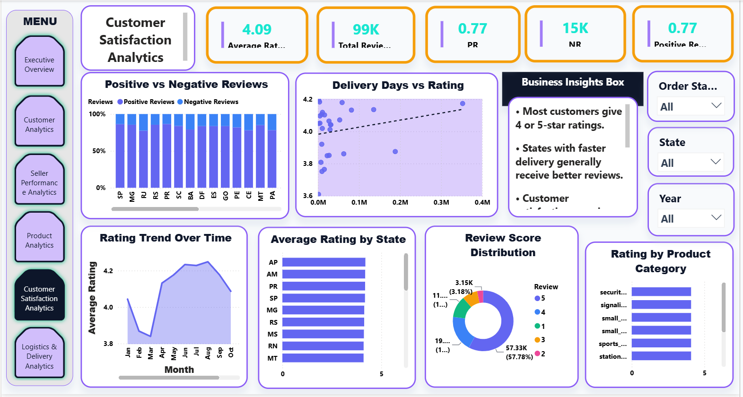
Page 5 – Customer Satisfaction
Purpose: Analyse review scores, satisfaction trends and the impact of delivery performance.

  - Most customer reviews were rated 4 or 5 stars, indicating positive shopping experiences.
  - Delivery performance had a direct impact on customer satisfaction scores.
  - Product categories with faster delivery generally received better ratings.
  - Negative reviews were limited to a small number of products and regions.
  - Improving delivery speed and service quality can further increase customer loyalty.

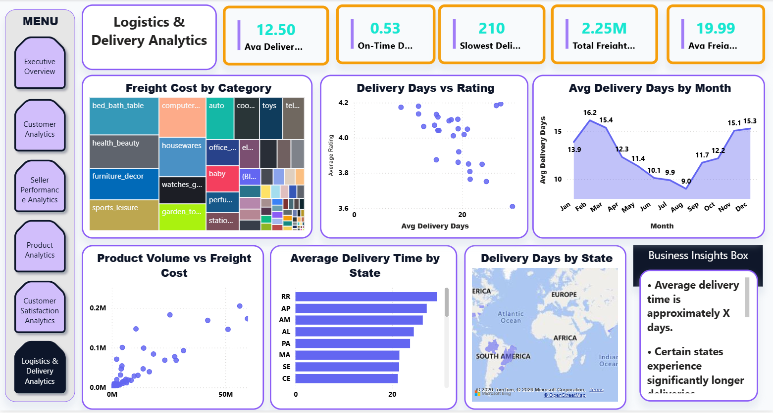
Page 6 – Logistics Analytics
Purpose: Evaluate delivery times, freight costs and operational efficiency.

- Average delivery time remained within an acceptable range for most orders.
- Certain states experienced longer delivery times than the overall average.
- Freight costs increased significantly for larger and heavier products.
- Faster deliveries were associated with higher customer satisfaction ratings.
- Optimizing logistics operations can reduce shipping costs and improve customer experience.

Business Insights

Example insights:
• Revenue is concentrated in a limited number of product categories.
• São Paulo contributes the largest customer base.
• Credit card payments account for the majority of transactions.
• Longer delivery times are associated with lower review scores.
• A small group of sellers generates a large proportion of revenue.
Replace these examples with findings from your completed dashboard.

Business Recommendations
Based on the dashboard, management should:
• Increase investment in top-performing product categories.
• Improve logistics in regions with long delivery times.
• Strengthen customer retention strategies.
• Reward high-performing sellers.
• Monitor low-rated categories and investigate root causes.

Technical Skills Demonstrated
Power BI Desktop
Power Query
Data Modelling
Star Schema
DAX
Data Visualisation
Business Intelligence
Dashboard Design
KPI Development
Analytical Storytelling

Conclusion
This project demonstrates the complete workflow required to deliver a professional Business Intelligence solution. It combines technical implementation with business understanding to transform raw data into actionable insights. The dashboard can support executives, analysts and operational teams in making informed, data-driven decisions.

